Taipei City 114 Academic Year, Second Semester
Elementary School Transnational Students Mandarin Support Program
- This program is implemented in accordance with the Taipei City Government’s Education Development Plan for Children of New Immigrants.
- Purpose
The Mandarin Group Support Program for Transnational Students aims to help students bridge the gap with elementary school curricula more effectively. By applying second language teaching methodologies, the program is expected to enhance students' listening, speaking, reading, and writing skills, ensuring a smooth transition into domestic school courses and local life in Taiwan.
- Organizer: Department of Education, Taipei City Government
- Implementer
- Xinghua Elementary School, Wenshan District, Taipei City
- Office of Prospering Ankang Benefiting Wenshan Project, National Chengchi University
- Course Schedule, Time, and Location
- Date: March 28 to July 4, 2026
- Class Time: Every Saturday, 10:30 a.m. – 3:00 p.m.
- Mode: In-person Classes
- Class Venues:
  - Class A: 3rd Floor, New Immigrants' Hall (Tentative)
(No. 171, Sec. 2, Changsha St., Wanhua District, Taipei City)
  - Classes B and C: Taipei Municipal Xinyi Junior High School (Tentative)
(No. 1, Ln. 158, Songren Rd., Xinyi District, Taipei City 110)
- Course Fee: Free
- Course Description
The curriculum is designed around topics from elementary school Social Studies subjects, integrating Taiwanese cultural content with language skills training. Through this approach, transnational students develop intercultural competence while gaining an understanding of Taiwan. For the detailed course syllabus, please see Appendix 3.
- Instructor
Instructors are graduate students specializing in Teaching Chinese as a Second Language.
- Eligibility
- Who Can Apply: Open to transnational elementary students in Taipei City. The program offers three classes (5–10 students each), with priority for returning students. Waitlisted applicants may join within the first three weeks; no admissions are allowed from Week 4 onwards.
- Target Students: Those from non-Mandarin-speaking regions or with mobile international backgrounds whose language skills are below grade level.
(Note: Students from Mainland China or new immigrant children who have not lived abroad may not qualify. Applications that do not meet these criteria will not be accepted.)
- Full Attendance: Students are expected to attend every class. A maximum of three leaves are allowed; exceeding this limit will affect your eligibility for future terms. Please do not enroll if you plan to leave Taiwan for longer period or relocate abroad during the semester. As this program is fully funded by the Department of Education and the NCCU USR Project, we require a full-term commitment from all admitted students to ensure that resources are used effectively and fairly for everyone.
- Student Responsibilities: Students are expected to follow the curriculum, comply with the instructor’s guidance (including health and safety protocols), and adhere to program safety regulations. and participate in the final presentation.
- Students who violate program rules and fail to improve after warnings will lose their eligibility for future terms.
- Application Period and Procedures
  - Deadline: March 6, 2026. The admission results will be announced on March 18.
  - Procedures
- Students must be recommended by their school counseling office or homeroom teacher.
- Schools are requested to assist students in completing the TOCFL Speedy Screening Mock Test on campus and to record the test results on the Application Form. For detailed instructions, please refer to Appendix IV.
- Please complete Appendix I (Application Form) and Appendix II (Parental Consent Form). After obtaining the official school seal, please scan the documents and email the PDF files to the following recipients:
      - Lin Wei-Ru, Education Officer (j29983@gov.taipei)
      - Chen Pin-Hong, Project Coordinator (cph@g.nccu.edu.tw)
      - Huang Li-Zhong, Project Assistant (114160502@g.nccu.edu.tw)
- After receiving the application materials, the Mandarin instructor will arrange an interview with the student and parents to assess Mandarin proficiency and assign the student to one of three classes.
- Applications are reviewed as they arrive. Once received, we will contact the school to schedule an online interview and provide further details.

- Important Notes
- At the beginning of the semester, a Course Information Session and Parent–Teacher–Student Meet-and-Greet will be held. The event is tentatively scheduled on Saturday, March 21, 2026, and will take place on the campus of National Chengchi University (NCCU). Detailed information will be announced along with the official admission list.
- In principle, this program discourages students from using electronic devices (such as mobile phones and tablets). If such devices are brought to class, they will be temporarily collected and kept by the teaching assistants and returned after the afternoon session concludes. In case of emergency during class hours, parents may contact students through the class communication group or via the teaching assistants.
- Students’ learning progress in this program will be documented by the USR Project team and shared with their original schools and parents, in order to assist schools and families in understanding students’ learning and adjustment status.
- All teachers and students are required to comply with relevant public health and epidemic prevention measures during class sessions.
- Image and video recordings will be conducted during the course and will be used solely for internal archival purposes of the project.
- For further inquiries, please contact the following program representatives:
  - Lin Wei-Ru, Education Officer. Tel: +886-2-2720-8889 ext. 1250
  - Chen Pin-Hong, Project Coordinator. Tel: +886-911897799
  - Huang Li-Zhong, Project Assistant Tel: +886-930506719
- This program shall be implemented upon approval by the Taipei City Government’s Education Development, and any subsequent amendments shall be subject to the same approval process.

Taipei City 114 Academic Year, Second Semester
Elementary School Transnational Students Mandarin Support Program
Application Process
Stage | Responsible Unit | Details
Application | Elementary Schools (Taipei City) | Confirm students’ need to enroll in the Mandering Support Program
Application | Elementary Schools (Taipei City) | ↓
Application | Elementary Schools (Taipei City) | Complete the Application Form and Parental Consent Form; scan the documents into PDF files and submit them via email to:  ①Lin Wei-Ru, Education Officer: j29983@gov.taipei  ②Chen Pin-Hong, Project Coordinator: cph@g.nccu.edu.tw  ③Huang Li-Zhong, Project Assistant:14160502@g.nccu.edu.tw  ＊After sending the email, please confirm receipt by phone.  ＊Application deadline: Friday, March 6, 2026
Review | Taipei City Government’s Education Development  NCCU USR Project | Review process (including online interviews) and Archive documents.  (From the application deadline until March 16, 2026)
Review |  | ↓
Review |  | Admission (class list), announcement of results and notification will be sent to applying schools via official correspondence along with relevant documents.  (Notification date: March 18, 2026)
Review | Elementary Schools (Taipei City) | - Inform students and parents of class dates and times.  - Reconfirm important notes in the class.  (By March 26, 2026)
Class Start | NCCU USR Project | - First day of class: March 28, 2026  - Attendance will be recorded at each class session.  - Course records will be completed after each class session.

【Appendix 1】
Taipei City 114 Academic Year, Second Semester
Elementary School Transnational Students Mandarin Support Program
Application Form
申請學校資料暨輔導紀錄調查 | School |  |  | School Address
申請學校資料暨輔導紀錄調查 | Principal |  |  | School Tel / Ext.
申請學校資料暨輔導紀錄調查 | Coordinator Name |  |  | Coordinator’s position
申請學校資料暨輔導紀錄調查 | Coordinator E-mail
申請學校資料暨輔導紀錄調查 | Interpreter provided this semester? |  | □ Yes, Agency: ______________________  □ No
申請學校資料暨輔導紀錄調查 | Any on-campus Mandarin support this semester? |  | □ Yes, Source of Instructor______________________  □ No
申請學校資料暨輔導紀錄調查 | Previous Mandarin Support (Interpreter or Tutor) |  | □ Interpreter Period: _____________________  □ On-campus Mandarin Tutor Period: ___________________  □ None
申請學校資料暨輔導紀錄調查 | Remedial Mandarin Classes |  | □ Yes, Period: ______________________  □ No
學生基本資料 | Student Name |  |  | Gender
學生基本資料 | Place of Birth |  |  | Date of Birth
學生基本資料 | ID/ARC No. |  |  | Passport No. (Non-citizens)
學生基本資料 | Nationality |  |  | English Name  (written in Passport)
學生基本資料 | Father |  |  | Nationality
學生基本資料 | Mother |  |  | Nationality
學生基本資料 | Residential Address
學生基本資料 | Home Country & Duration |  |  | Arrival Date in Taiwan
學生基本資料 | Emergency Contact |  |  | Relationship
學生基本資料 | Phone Number
學生基本資料 | Email
學生基本資料 | Language(s) used at home |  |  | Parents' Native Language | Father：  Mother：
學生基本資料 | Language Proficiency Ranking (Example:  1. Vietnamese 2. English 3. Mandarin) |  | 1. | Enrollment Year
學生基本資料 |  |  | 2. | Enrollment Year
學生基本資料 |  |  | 3. | Enrollment Year
學生基本資料 | School grade placement |  |  | Age-Appropriate Grade
學生基本資料 | Special Needs |  | □ None  □ Allergies, Dietary Restrictions, or Major Medical History,  Description:＿＿＿＿＿＿＿＿＿＿＿＿＿＿＿＿  □ Special Education Needs, e.g., ADHD, Dyslexia,  Description:＿＿＿＿＿＿＿＿＿＿＿＿＿＿＿＿
學生基本資料 | Siblings who are also transnational students (elementary or junior high school) |  | □ Yes. Name ________________ School: ________________  Grade: ____  □ No
中文程度評估 | Listening | ☐ Can understand basic phrases and commonly used words  ☐ Can understand short, simple, and slow explanations  ☐ Can understand the main ideas and key details of conversations |  |  |  | (Other)
中文程度評估 | Speaking | ☐ Can produce simple phrases and sentences  ☐ Can describe people, events, and things in daily life using connected sentences  ☐ Can respond to others using accurate and appropriate sentences |  |  |  | (Other)
中文程度評估 | Reading | ☐ Can read basic everyday vocabulary and understand the meaning of short phrases  ☐ Can understand short texts written using everyday vocabulary  ☐ Can understand topic-based texts written in a conversational style |  |  |  | (Other)
中文程度評估 | Writing | ☐ Can write simple short sentences  ☐ Can write short texts using basic everyday vocabulary  ☐ Can write topic-based texts using accurate sentences |  |  |  | (Other)
華測快篩模擬測驗成績 | Listening | ☐ Mock test completed  Scale Score: _______________ Speedy Screening Level: _______________  ACTFL Level: _______________ TBCL Level: _______________  ☐ Mock test score screenshot attached
華測快篩模擬測驗成績 | Reading | ☐ Mock test completed  Scale Score: _______________ Speedy Screening Level: _______________  ACTFL Level: _______________ TBCL Level: _______________  ☐ Mock test score screenshot attached

Applicant (Signature) Officer in Charge

Division Director Principal

【Appendix 2】
Parental Consent Form
Taipei City 114 Academic Year, Second Semester
Elementary School Transnational Students Mandarin Support Program

I hereby consent for my child ____________________ to participate in the Taipei City Government Department of Education’s 114 Academic Year Second Semester Elementary School “Transnational Students Mandarin Support Program.”

After enrollment, my child must comply with all regulations of the program, including guidance (such as epidemic prevention), class video recording,teacher/classroom assistant home visits, and related matters. My child shall also abide by the rule of not being absent for more than 3 consecutive days without valid reasons.

If my child’s total absences exceed the specified limit, or if they violate the class regulations and fail to improve after counseling, I agree that my child will not be allowed to reapply for this program in the following semester.

Sincerely,
Taipei City Department of Education

Parent/Guardian Signature (Please sign full name or affix seal): __________
Relationship to Student: ____________
Parent Contact Phone Number: ____________

Republic of China (Taiwan) Year 115 Month ________ Day ________
【Appendix 3】
Taipei city 114 Academic year 2nd Semester of Elementary School
– Transnational Students’ Mandarin Support Program
【Class A】 Curriculum
Week /  Date | 【Morning Session】10:30~12:00 |  | 【Afternoon Session】13:30~15:00
Week /  Date | Topic | Content | Topic | Content
3/21(Sat) | 13:00~16:00 Greeting Day
Week 1  28/3 | Getting to Know Myself and Our Class | Kang Hsuan Grade 1 Life Education – “Let’s Play Together”  • Getting to know the class and classmates  • Group games | Chinese Characters and Me | Kang Hsuan Grade 2, Semester 2, Theme 6 – “My Growth Story”  • Interesting ancient Chinese characters  • Basic stroke order and structure  • Creating name stories
Week 2  04/4 | Children’s Day & Tomb-Sweeping Day – No Class
Week 3  11/4 | Healthy Living | Hanlin Grade 3, Semester 1 Social Studies – “A Happy and Growing Childhood”  • Developing healthy living habits  • The importance of privacy  • Learning to get along with others | Emotion Observation | Nani Grade 3, Semester 1 Unit 2 – “Emotion Observation Station”  • Different kinds of emotions  • Turning emotions around
Week 4  18/4 | Daily Routines | Kang Hsuan Grade 4, Semester 1 Social Studies – “Daily Life in My Hometown”  • Understanding traditional daily routines  • Effective time management  • Planning one’s day | Internet Safety | Kang Hsuan Grade 5, Semester 1 Unit 1 – “Taiwan, My Home”  • How laws affect our lives
Week 5  25/4 | I Love Reading | Kang Hsuan Grade 1 Life Education – “Making Friends with Books”  • Where books come from  • Sharing favorite books  • Bookmark making | The World of Colors | Kang Hsuan Grade 2, Semester 2 Theme 5 – “The Colorful World”  • Discovering colors  • Colors expression  • Article appreciation and five-senses short writing
Week 6  02/5 | Disaster Prevention Experts | Kang Hsuan Grade 2 Life Education – “Earthquake Prevention Experts”  • Understanding disasters and prevention  • Typhoons, fires, earthquakes | Population and Life in My Hometown | Hanlin Grade 4, Semester 1 Unit 3 – “Population and Life in My Hometown”  • Population composition  • Population changes and development
Week 7  09/5 | Toy Story | Kang Hsuan Grade 1 Life Education – “Toy Story”  • Traditional toys and modern toys  • Functions of toys | Getting to Know Where We Live | Nani Grade 3, Semester 2 Unit 1 – “Getting to Know Where We Live”  • Ways to understand one’s living environment
Week 8  16/5 | Transportation in My Hometown | Kang Hsuan Grade 4, Semester 2 Social Studies – “Transportation in My Hometown”  • Transportation systems  • Information transmission | Mountains of My Hometown | Hanlin Grade 4, Semester 2 Unit 2 – “Mountains and Seas of My Hometown”  • Forest development and changes
Week 9  23/5 | Learning to Read Maps | Hanlin Grade 3, Semester 1 Social Studies – “Maps of My Hometown and Their Use”  • Using maps effectively  • What to do when lost | Seas of My Hometown | Hanlin Grade 4, Semester 2 Unit 2 – “Mountains and Seas of My Hometown”  • Development and protection of fisheries
Week 10  31/5 (Sun) | Field Trip
Week 11  06/6 | Smart Consumer Awareness | Kang Hsuan Grade 3, Semester 2 Social Studies – “Consumption and Life”  • Consumption habits  • Allowance management  • Impact of consumption | Old Stories of My Hometown | Hanlin Grade 4, Semester 2 Unit 4 – “Old Stories of My Hometown”  • Preservation of cultural artifacts  • Traditional architecture
Week 12  13/6 | Celebrating the Dragon Boat Festival | Kang Hsuan Grade 1 Life Education – “Celebrating the Dragon Boat Festival on the Fifth Day of the Fifth Lunar Month”  • Dragon Boat Festival customs  • Understanding traditional festivals | Taiwanese Festivals | • Stories of the Dragon Boat Festival and hands-on activities
Week 13  20/6 | Dragon Boat Festival – No Class
Week 14  27/6 | Taiwan During the Japanese Colonial Period | Hanlin Grade 5, Semester 2 Social Studies – “Taiwan under Japanese Rule”  • From Qing rule to Japanese rule  • Impact of Japanese rule on Taiwan | History of Taiwan | Hanlin Grade 5, Semester 2 Unit – “Cultural Expressions in Daily Life”  • Taiwan’s diverse rice-based food culture  • How architecture reflects culture and lifestyle
Week 15  04/7 | No class in the Morning |  | 13:00~16:00 Final Presentation at NCCU: Chinese song performances, drama performances

Taipei city 114 Academic year 2nd Semester of Elementary School
– Transnational Students’ Mandarin Support Program
【Class B】 Curriculum
Week/  Date | 【Morning】10:30~12:00 | 【Afternoon】13:30~15:00
Week 1 (3/21) | 13:00~16:00 Greeting Day
Week 2  (3/29)  Sunday | Warm-up  (Kang Hsuan Mandarin, Grade 1, Semester 2, wrap-up activity : I can introduce myself)  - Self-introduction:  Zodiac sign, Chinese zodiac animal, birthday  - Describe personality traits  - Gett to know new classmates  - Learn classroom language and rules  - Ice-breaking activities | New Semester, New Hopes  (Kang Hsuan Mandarin, Grade 2, Semester 1, Theme 1, Lesson 1: New Semester, New Hopes)  - In the new semester, what new hopes or goals do you have?  - Sentence : “I hope to…, and I also want to…”  - Picture-based storytelling
Week 3 (4/4) | Children’s Day National Holiday-No Class
Week 4 (4/11) | My breakfast  (Kang Hsuan Mandarin, Grade 2, Semester 1, Theme 1: Let’s make breakfast together)  - Introduce my breakfast  - Traditional breakfast in Taiwan  - breakfast in different countries | A Healthy Breakfast  (Kang Hsuan Mandarin, Grade 2, Semester 1, Theme 1: Let’s make breakfast together)  - The importance of breakfast  - A nutritious breakfast:  what makes a healthy breakfast?  - Dialogue practice and role-play:  Buying breakfast
Week 5 (4/18) | Managing My Time  (Hanlin Mandarin, Grade 3, Semester 1, Theme 1, Lesson 3:Five Minutes Earlier)  - Review how to tell time  - My daily schedules:  What time do you usually go to school, leave school, and go to bed?  - Share experiences:  Have you ever been late or forgotten to bring something?  - Practice expressions of frequency  (e.g., how often, how many times) | Planning My Time  (Hanlin Mandarin, Grade 3, Semester 1, Theme 2, Lesson 5 :The Magic of Sticky Notes)  - Review expressions of frequency  (sometimes, often, always)  - Discuss strategies:  How can we avoid being late or forgetting to bring things?  - Practice time planning:  Using sticky notes or blank paper to write down and organize tasks
Week 6 (4/25) | My Pencil Case  (Hanlin Mandarin, Grade 1, Semester 2, Theme 4, Lesson 11: Pencils and Erasers)  - Introduce stationery items and measure words  - Introduce my pencil case  What’s in my pencil case?  What color is it?  - Sentence pattern: I use … to write / draw / draw straight lines … | My School bag  (Hanlin Mandarin, Grade 1, Semester 2, Theme 4, Lesson 11: Pencils and Erasers)  - Review stationery items and measure words  - Introduce my school bag  What’s in my school bag?  What color is it?  - Dialogue practice and role-play  Buying stationery at a stationery store
Week 7  (5/2) | My Home  (Nan Yi Mandarin, Grade 2, Semester 2, Theme 4, Lesson 12: If It Were My Room)  - Introduce spaces in the home  (kitchen, restroom, bathroom, study, living room)  - Introduce my home  - Draw my home | My Room  (Nan Yi Mandarin, Grade 2, Semester 2, Theme 4, Lesson 12: If It Were My Room)  - Review spaces in the home  (kitchen, restroom, bathroom, study, living room)  - Introduce furniture in different spaces at home  - Talk about what’s in each room  - Introduce my room (or a family member’s room)  - Storytime
Week 8 (5/9) | What Job Is This?  (Nan Yi Mandarin, Grade 3, Semester 1, Theme 3, Lesson 9: The Doctor in a White Coat)  - Introduce common jobs  (doctor, police officer, chef, driver, singer, etc)  - Guessing game: What job is this?  - My dream job:  - What do you want to be when you grow up? | I don’t feel well.  (Nan Yi Mandarin, Grade 3, Semester 1, Theme 3, Lesson 9: The Doctor in a White Coat)  - Who works in a hospital?  - What happens when you are sick?  (cough, runny nose, headache, fever)  - Dialogue practice and role-play:  See a doctor
Week 9 (5/16) | School Sports Competition  (Kang Hsuan Mandarin, Grade 2, Semester 1, Theme 2-4: Sports Day)  - Learn common school sports (sprint, tug-of-war, relay, soccer, badminton, volleyball, basketball, dodgeball, table tennis)  - Observe sports clothing and equipment  - Use adverbs (don’t like → love) to express interest | I Wanna Try a New Sport  (Kang Hsuan Mandarin, Grade 2, Semester 1, Theme 2-4: Sports Day)  - Review school sports  - Introduce other sports in Olympic or national games (weightlifting, taekwondo, archery, athletics, gymnastics, baseball, golf, swimming)  - Introduce a model athlete  - Share which new sport you want to try
Week 10 (5/23) | Field Trip (exact location to be confirmed)
Week 11  (5/30) | Is It My Needs or Wants?  (Nan Yi Social Studies, Grade 3, Semester 2, Theme 3-1: Rational Consumption)  - Learn to distinguish needs vs. wants in daily items  - Compare store discounts and prices  - Practice using “…is more…than…” (expensive, cheap, needed) to describe comparison  - Final Presentation Preparation | How to Be a Money-Savvy Kid  (Nan Yi Social Studies, Grade 3, Semester 2, Theme 3-2: Saving as the Basis of Financial Management)  - Learn ways to save money and their benefits  - Plan how to spend a set budget on desired items  - Discuss how to use money to help others  - Final Presentation Preparation
Week 12  (6/6) | How to Be a Smart Consumer  (Hanlin Social Studies, Grade 3, Semester 2, Theme 5-3: Good Shopping Habits)  - Learn different payment methods  - Observe product prices and quality (expiration date, packaging, ingredients)  - Practice using “…first…, then…” to describe shopping steps  - Final Presentation Preparation | How to Be a Responsible Consumer  (Hanlin Social Studies, Grade 3, Semester 2, Theme 5-3: Good Shopping Habits)  - Review recyclable and non-recyclable items  - Check product packaging for recyclability  - Role-play convenience store shopping  - Final Presentation Preparation
Week 13  (6/13) | Dragon Boat Festival – No Class
Week 14  (6/20) | Passing Through the Tunnel  (Hanlin Mandarin, Grade 2, Semester 1, Theme 1-3: Passing Through the Tunnel)  - How do you usually go to school?  - Introduce different modes of transportation  - Talk about your favorite means of transportation  - Compare different modes of transportation  - Sentence pattern: “…is more (fast, slow, cheap, expensive) than…”  - Final Presentation Preparation | Passing Through the Tunnel  (Hanlin Mandarin, Grade 2, Semester 1, Theme 1-3: Passing Through the Tunnel)  - Safety rules for different modes of transportation  - Review commonly visited locations  - Dialogue practice and role-play:  Where are you going?  I’m going to (location).  How will you get to (location)  I’m going by MRT / by bus / on foot.  - Final Presentation Preparation
Week 15  (6/27) | My Colorful Feelings Journal  (Nan Yi Mandarin, Grade 2, Semester 2, Theme 1-1: Colorful Emotions)  - Learn words related to emotions (happy, sad, angry, nervous, touched, scared, shy)  - Explore how to represent emotions with colors and describe why  - Practice using “Because (what happened), I feel (emotion)” to describe feelings  - Final Presentation Preparation | I Wanna Be a Brave Hero  (Nan Yi Mandarin, Grade 2, Semester 2, Theme 1-2: Brave Hero)  - Reflect on feelings when mistakes happen or things get broken  - Discuss possible actions after an incident and what a brave person would do  - Draw or describe your idea of a brave hero  - Final Presentation Preparation
Week 15  (7/4) | No class in the Morning | 13:00~16:00 Final Presentation at NCCU

Taipei city 114 Academic year 2nd Semester of Elementary School
– Transnational Students’ Mandarin Support Program
【Class C】 Curriculum
＊The curriculum is organized into monthly thematic units, integrating materials from the Overseas Community Affairs Council (OCAC) and using picture books for exploration and instructional support.
Week/  Date | 【Morning】10:30~12:00 | 【Afternoon】13:30~15:00
3/21  (Sat) | 13:00~16:00 Greeting Day
Week 1  28/3 | Getting to Know Me and Our Class
Week 2  04/4 | Children’s Day & Tomb-Sweeping Day – No Class
Week 3  11/4 | International Children's Day & Cultural Exploration (I)  - Understanding International Children's Day  - Sharing differences between Children's Day in students' home countries and Taiwan
Week 4  18/4 | International Children's Day & Cultural Exploration (II)  - Exploring themes through picture books  - Learning vocabulary related to traditional toys and introducing favorite toys
Week 5  25/4 | International Children's Day & Cultural Exploration (III)  - Introduction to popular Children's Day locations in Taipei  - Hands-on activity: "My Favorite Children's Day"
Week 6  02/5 | Gratitude and Daily Practice (I)  - Learning how Mother's Day is celebrated around the world  - Hands-on activity: Making Mother's Day cards
Week 7  09/5 | Gratitude and Daily Practice (II)  - Picture book exploration (focusing on different professions and family themes)  - Learning vocabulary for occupations, household chores, and expressions of gratitude
Week 8  16/5 | Gratitude and Daily Practice (III)  - Introduction and discovery of students' home countries
Week 9  23/5 | Field Trip
Week 10  30/5 | Physical Activity and Health
Week 11  06/6 | Celebrating Dragon Boat Festival (I)  - Introduction to customs and traditional festival origins
Week 12  13/6 | Celebrating Dragon Boat Festival (II)  - Dragon Boat Festival stories and hands-on crafts
Week 13  20/6 | Dragon Boat Festival -No Class
Week 14  27/6 | Semester Review & Final Presentation Rehearsal
Week 15  04/7 | No class in the Morning |  | 13:00~16:00 Final Presentation at NCCU

Primary Textbook: Elementary School Social Studies Textbooks
Supplementary Materials: Language and culture resources (OCAC).
Note:
※Course content is subject to change based on students’ backgrounds and learning needs.
※For selected materials, please scan the QR code below to review the content and evaluate whether the level is appropriate for your students.


【Appendix 4】
TOCFL Speedy Screening: Instructions
Step 1:
Go to the TOCFL website (https://tocfl.edu.tw). Click "Visitor," select "TOCFL-Speedy Screening," and then click "Mock Test" to access the registration page.

Step 2:
Register with an email address (recommended: the teacher-in-charge’s email). After registration, you will receive a test link and separate login credentials for the Listening and Reading tests.
Each login can be used only once, so please log in only after the student and equipment are ready. The two tests together take about one hour.

Step3:
After each test, the score will appear immediately on the screen. Please record the Listening and Reading scores and fill them in the application form (Appendix 1) or provide clear screenshots or photos of the score pages.

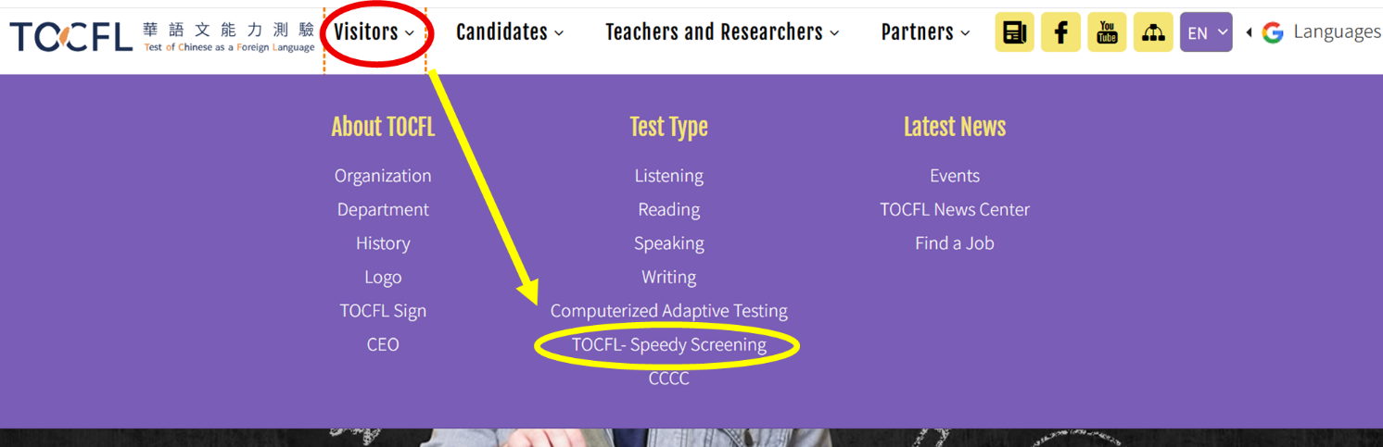
↓
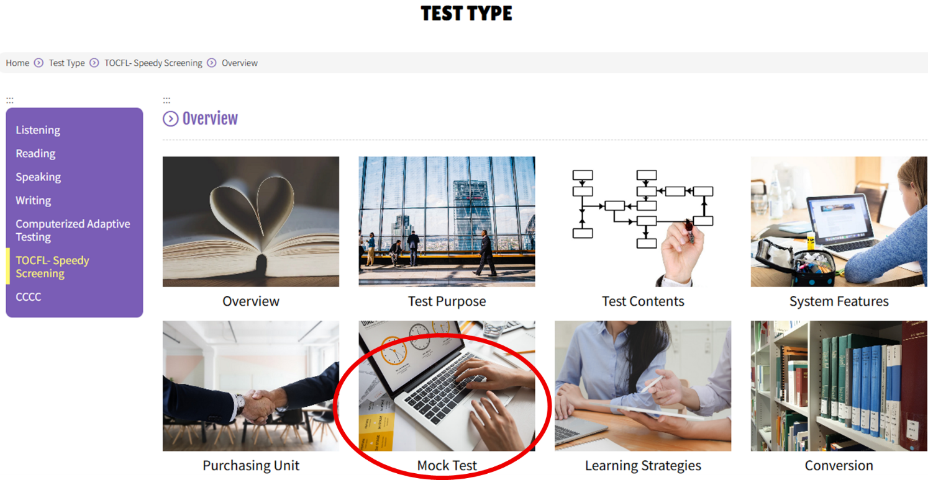
Step 2:
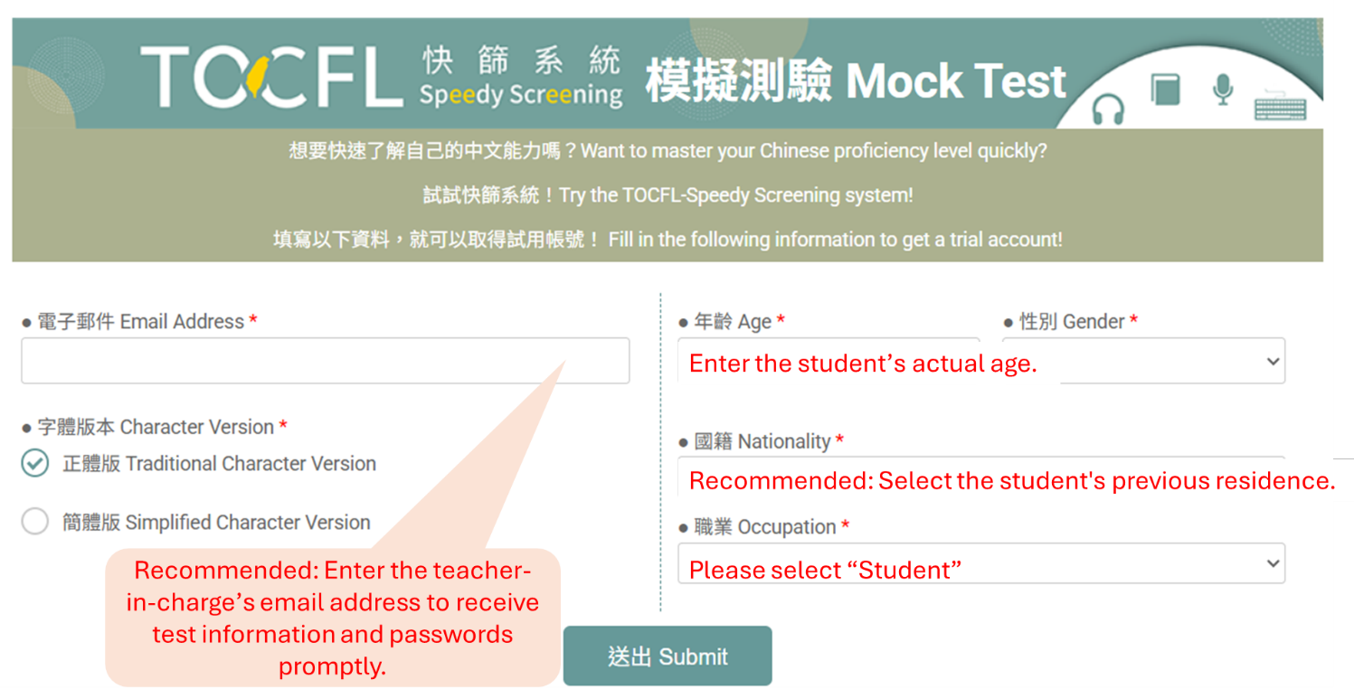

↓

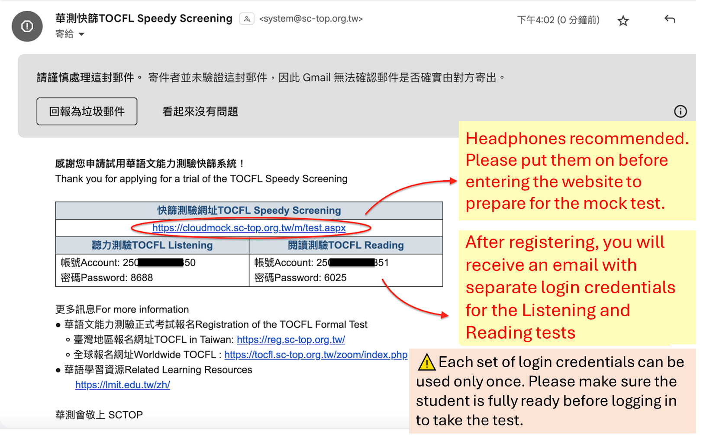

Step3:






